Synopsis

Air Quality Level Classification System Using Machine Learning
Problem Id:

Student Name: Devesh Saini
University Roll number:2028706
Section: P

Student Name: Harshita Joshi
University Roll number:2028427
Section: P

Student Name: Anmol Gupta
University Roll number:2028644
Section: P

- Problem Description:
- Air pollution is a critical environmental issue affecting human health and ecosystems. Monitoring and predicting air quality levels is essential for taking preventive actions and ensuring public safety. However, raw sensor data alone does not provide meaningful insights without proper analysis.
- This project aims to develop an Air Quality Level Classification System using Machine Learning. The system uses environmental sensor data such as CO (Carbon Monoxide), NO₂ (Nitrogen Dioxide), Temperature, Humidity, along with contextual information like city, disease conditions, and past medical records to classify air quality into categories such as Good, Moderate, and Poor.
- By incorporating both environmental and health-related parameters, the model can better understand how pollution affects individuals with different medical conditions. Data preprocessing techniques such as handling missing values, noise removal, categorical encoding, and feature scaling are applied. Feature selection helps retain important pollution indicators and remove less useful attributes.
- The classification is performed using K-Nearest Neighbors (KNN) , Logistic Regression algorithms , Decision Tree and Support Vector Machines(SVM). The models are evaluated using accuracy, precision, recall, and F1-score. This system can assist in environmental monitoring and provide health-aware air quality recommendations.
- Steps of Implementation:
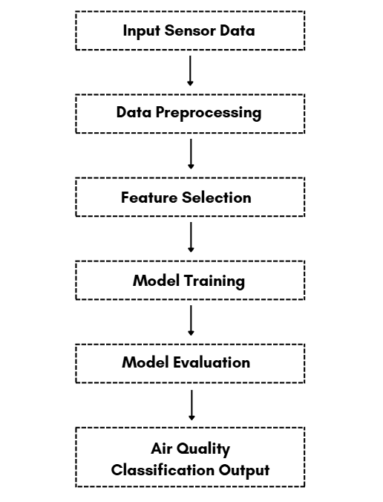

- Expected Modules/ Libraries to be used :
- NumPy
- Pandas
- Matplotlib
- Seaborn
- Scikit-learn
- StandardScaler
- LabelEncoder / OneHotEncoder
- KNeighborsClassifier
- LogisticRegression
- train_test_split
- sklearn.metrics
- DecisionTreeClassifier
- SVC

- Expected Evaluation metrics and Plots to be used:
Evaluation Metrics
- Accuracy – Overall correctness of predictions
- Precision – Correctness of positive predictions
- Recall – Ability to detect actual positive cases
- F1 Score – Balance between precision and recall
- Confusion Matrix – Detailed performance evaluation
Visualization Plots
- Confusion Matrix Heatmap
- Correlation Heatmap
- Scatter Plots
- Histogram / Distribution Plots
- Required topics from the subject:
- Python Basics: Variables, data types, and operators used in ML implementation
- NumPy & Arrays: Efficient numerical computation and data handling
- Pandas DataFrames: Data manipulation, cleaning, and preprocessing
- Data Visualization: Graphical representation using Matplotlib and Seaborn
- Machine Learning Concepts: Supervised learning, classification, and model evaluation

Platform Required:
Visual studio/ jupyter notebook
- Books and Link Sources:
- Hands-On Machine Learning with Scikit-Learn & TensorFlow – Aurélien Géron
- Introduction to Machine Learning with Python – Andreas Müller
- Scikit-learn Documentation – https://scikit-learn.org
- Kaggle (Datasets & Tutorials) – https://www.kaggle.com
- Python Documentation – https://docs.python.org
Prompt Used for Dataset Generation:
“Generate a dataset for an Air Quality Level Classification System using machine learning. The dataset should include the following columns: CO, NO2, Temperature, Humidity, city, disease, past_medical_record, and Air_Quality.
The dataset should simulate realistic environmental and health conditions:
• CO and NO2 values representing pollution levels
• Temperature and Humidity showing atmospheric variations
• Multiple city categories to represent different locations
• Disease column indicating respiratory conditions such as asthma, bronchitis, or none
• past_medical_record showing previous health history (yes/no or categorical)
• Air_Quality categories such as Good, Moderate, and Poor
Additionally include:
• Random noise in sensor readings
• Missing (null) values in some entries
• Outliers in pollution measurements
• Slight variability in weather conditions
• Balanced distribution of Air_Quality classes
The dataset should be large enough for machine learning training and testing and reflect real-world air quality monitoring scenarios.”

